2020-2021 Collaborative Grant Writing Workshop Series
Session 2: Proposal Development Handout

1) Local Proposal Example: “FY21 Early Care & Education Wrap Around Grant Application”* – MDE GEER Fund 2020 through Southern MN Initiative Foundation – https://smifoundation.org – Funding: up to $10,000
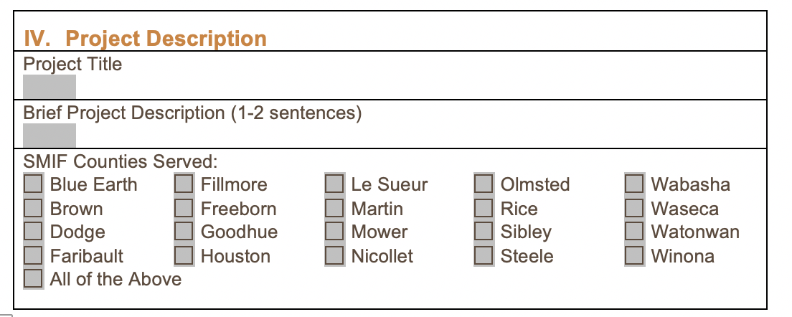
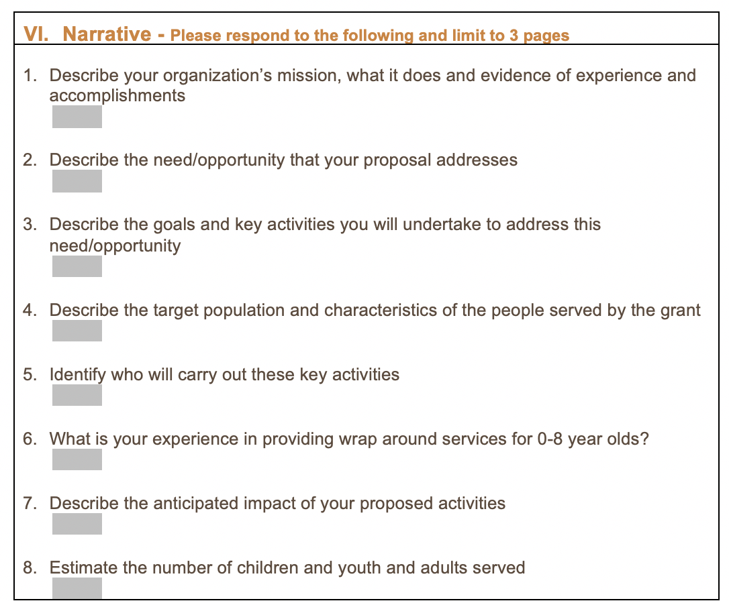

2) Federal Proposal Example: “Maternal and Child Health Bureau Division of Maternal and Child Health Workforce Development”* – U.S. Department of HHS – Health Resources & Services Administration - https://mchb.hrsa.gov/training/healthy-tomorrows.asp – Funding: up to $50,000/year for 5 years
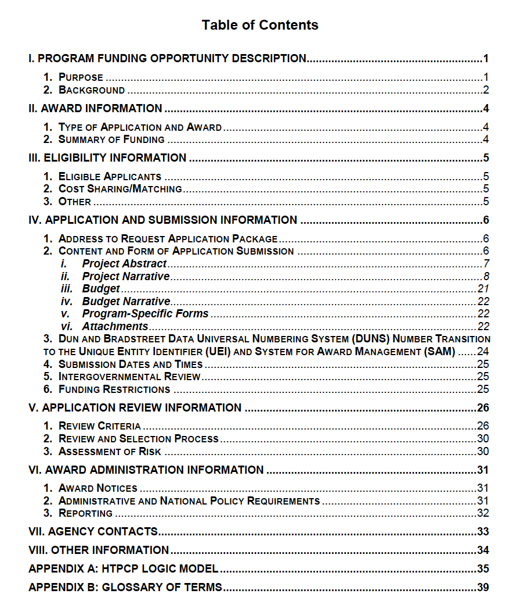
There could easily be a dozen or more attachments!
Included below
Application Page Limit:
65 Pages!

**Please note sections below are abbreviated and adapted from original NOFO. The 2.5 pages below were originally described in 14 pages of prescriptive application components.**
- Project Abstract
See Section 4.1.ix of HRSA’s SF-424 Application Guide.
The body of the abstract should adhere to the following format:
- Problem:
- Goals and Objectives:
- Methodology:
- Coordination:
- Evaluation:

ii. Project Narrative
This section provides a comprehensive framework and description of all aspects of the proposed project. It should be succinct, self-explanatory, consistent with forms and attachments, and well-organized so that reviewers can understand the proposed project. Successful applications will contain the information below.

Please use the following section headers for the narrative:
- INTRODUCTION -- Corresponds to Section V’s Review Criterion #1
Briefly describe the purpose of the proposed project.

- NEEDS ASSESSMENT -- Corresponds to Section V’s Review Criterion #1 Provide a clear description of the status, capacity and needs of the disparate population(s) living in the proposed project area. Please include and/or describe the following in this section:
  - Problem and associated factors that contribute to the identified problem.
  - Clear and succinct description of the unmet health need(s) and health and health care disparities of the community and target population to be served in the proposed project. Include socio-cultural determinants of health that impact the population or communities served.
  - An adequate description of cultural and linguistic needs of the proposed target population for the project. You should also document how your project will address disparities and inequalities in your service settings (e.g., staff recruitment, training, and professional development), and through recruitment of diverse families and community members to participate in the project Advisory Board(s).
  - Other relevant data that justifies a strong need for the interventions/activities proposed in your application. Provide a reference for all data sources. Use demographic data and cite data sources whenever possible to support the information provided.

- METHODOLOGY -- Corresponds to Section V’s Review Criteria #2 and #4
- Description of the Proposed Project. Describe how the proposed project represents either a new initiative, or a new component that will build upon, expand, and enhance an existing initiative, to address the identified need(s) of the target population. Your application is expected to clearly explain that the proposed intervention is new (i.e., program that has never existed) or a new component of an existing activity (i.e., expanding services by adding a new component, for example, the addition of a registered dietician who will implement a healthy weight promotion intervention at a school-based health clinic).
- Project Goals and Objectives. Clearly identify project goals and objectives that are responsive to the identified needs of the target population, and consistent with the purpose and requirements of the HTPCP. Objectives should be specific, measurable, attainable/achievable, relevant, and time-framed (SMART).
- Description of Project Activities. Provide a clear description of the proposed service intervention and other proposed project activities. Proposed project activities should be clearly linked to project goals and objectives and should be feasible and reasonably expected to lead to achievement of those goals and objectives within the period of performance. Discuss development of effective tools and strategies for ongoing staff training, continuing education for community-based MCH health professionals, outreach, collaborations, clear communication, and information sharing/dissemination with efforts to involve patients, families and communities of culturally, linguistically, socioeconomically and geographically diverse backgrounds.
- Development and Maintenance of Collaborative Relationships. Discuss how you will develop and/or maintain collaborative relationships between the proposed project, the state Title V MCH Program, other MCH-related agencies, and the state AAP Chapter.
- Plan for Pediatrician/Pediatric Primary Care Provider Involvement. Discuss how pediatricians/pediatric primary care providers will be substantively involved in the proposed project. An important objective of HTPCP is to involve pediatricians and other pediatric primary care providers (family physicians, nurse practitioners, physician assistants) in community-based service programs.
- Project Advisory Board. Discuss your plans for an Advisory Board to oversee the HTPCP project. The HTPCP recipient is expected to establish and maintain an Advisory Board specific to the HTPCP award; alternatively, the recipient may utilize an existing board as the project Advisory Board, if it will provide HTPCP project-specific direction and oversight during project implementation. HTPCP projects are exp
- Cost Sharing/Matching. Discuss plans for securing resources to fulfill the 2:1 non-federal program-matching requirement in years 2 through 5 of the 5-year period of performance that was discussed on Page 5 of the NOFO.
- Bright Futures. MCHB requires HTPCP award recipients to develop proposals that incorporate and build upon the goals, objectives, guidelines, and materials of the Bright Futures for Infants, Children, and Adolescents initiative to improve the quality of health promotion and preventive services in the context of family and community.

- WORK PLAN -- Corresponds to Section V’s Review Criteria #2 and #4
Describe the activities or steps that you will use to achieve each of the activities proposed during the entire period of performance in the Methodology section. Provide a timeline that includes each activity and identifies responsible staff.
Include the work plan in Attachment 1.

Logic Model
Submit a logic model for designing and managing the project. A logic model is a one-page diagram that presents the conceptual framework for a proposed project and explains the links among program elements. While there are many versions of logic models, for the purposes of this notice, the logic model should summarize the connections between the:
• Goals of the project (e.g., reasons for proposing the intervention, if applicable);
• Assumptions (e.g., beliefs about how the program will work and support resources. Base assumptions on research, best practices, and experience.);
• Inputs (e.g., organizational profile, collaborative partners, key staff, budget, other resources);
• Target population (e.g., the individuals to be served);
• Activities (e.g., approach, listing key intervention, if applicable);
• Outputs (i.e., the direct products or deliverables of program activities); and
• Outcomes (i.e., the results of a program, typically describing a change in people or systems).

- RESOLUTION OF CHALLENGES -- Corresponds to Section V’s Review Criterion #2
Discuss challenges you will likely encounter in designing and implementing the activities described in the work plan, and approaches you will use to resolve such challenges.

- EVALUATION AND TECHNICAL SUPPORT CAPACITY -- Corresponds to Section V’s Review Criteria #3 and #5 Describe and submit a preliminary project evaluation plan that will contribute to continuous quality improvement. Include the evaluation plan in Attachments 10–15. The plan should link the goals and objectives of the project to data collection activities.

- ORGANIZATIONAL INFORMATION -- Corresponds to Section V’s Review Criterion #5
Provide information on your organization’s current mission and structure, history, past experiences, and scope of current activities. Describe how the organizational structure and experience is appropriate to implement the program requirements and meet program expectations. Provide an organizational chart in Attachment 6 that shows the structure for the administrative and fiscal management team and reporting line for staff.

3) Internal Federal Checklist Example:
HRSA Healthy Tomorrows Grant To-Do List (2020 / 09 / 18)
Workspace #
Workspace Document | Type | Slot | Resp. Person | Status
SF-424 | Form | SF-424  15 |  | Needs project dates, project title / description, final budget total,  Abstract  Signed on submission
Attachments. | Doc | 1  2  3  4  5  6  7  8  9  10  11-14  15 |  | Workplan  Logic model  Staffing plan, key personnel PDs  Biosketches key personnel  Letters agreement  Org chart  Tables, charts  Fifth-year budget if needed  Advisory board roster  Evaluation plan  Support letters  Indirect cost agreement
Performance site locations | Form | PSL
Project narrative attachment | Doc | PNA
Disclosure lobbying | Form | DL
Budget narrative attachment | Doc | BNA
Budget information non-construction | Form | BINC
Key contacts | Form | KC
Formatting all narrative information (abstract, narrative, budget narrative):
- 1-in margins all sides
- 12-point font – Times New Roman or Arial
- Left aligned text; single spaced okay
- Section headers in bold, flush left
- Applicant name (Winona State University) in footer of each page
- Narrative 65-page limit includes:
- Abstract (1-page limit)
- Project narrative (does not include TOC)
- Budget narrative (5-page limit)
- Support letter(s)
- Other attachments (does not include Indirect Cost Agreement)

