Video Submission Instructions

For project introduction videos or creative exhibitions, we are asking all videos to be submitted to the Symposium Platform through YouTube upload. You will be uploading your video as “Unlisted” so it will not be searchable on YouTube, but will be accessible to those who are provided the link. You can find a step-by-step process to uploading your video here:

- Go to youtube.com and sign in or create an account. Use a professional email rather than your private email. For help creating a YouTube account, visit this link: https://youtu.be/jT9ScMAe5yQ.
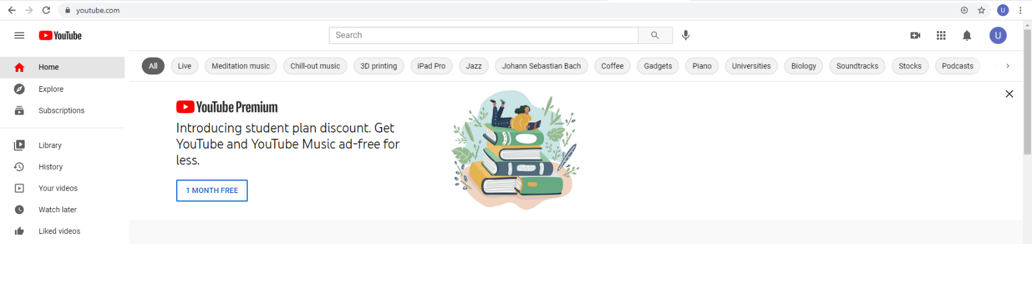
- On the top-right corner of your screen, click on the camera symbol with the addition sign in the center (see below).
- From the drop-down list, select the Upload video option. 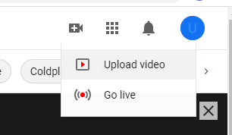

- You will be prompted in a new screen to upload your video file. Click the Select Files button and select the corresponding video file from your computer.
- Select the Edit button to edit the details of your video. Under the Details list you should specifically edit your:
  - Video title – This should match your presentation title.
  - Description – You may consider putting your abstract here or the names of student presenters.
- Under the Video Elements list, select whether or not your video is made for kids. (Note: You will be listing this video as Unlisted, so children will not have access through searching YouTube to it anyway.)

- Under the Visibility list, select the Unlisted option. This will not make your video searchable on YouTube but will allow viewing to anyone with a link you provide.

- Hit Save in the lower right corner to finish uploading your video. Once your video is uploaded, click the Options button next to your video. 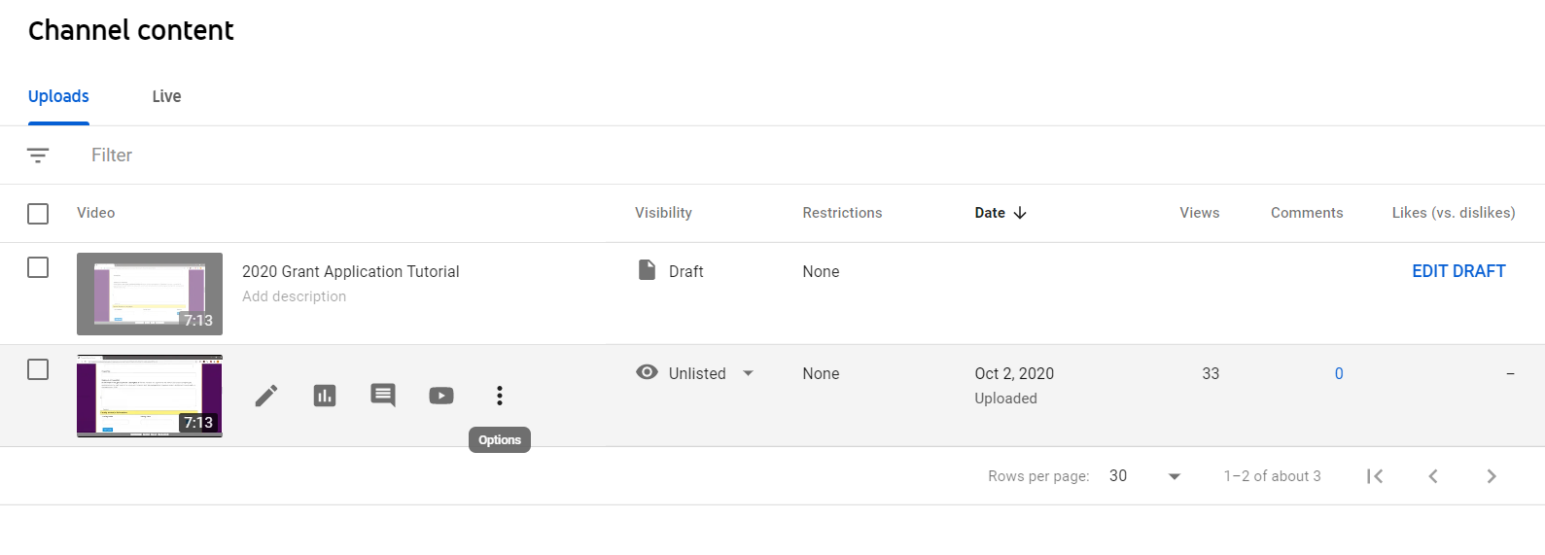
- Select the Get Sharable Link option from the drop-down. This will automatically copy the link. You will paste this into the online submission form on Symposium when you submit your materials.

PDF Formatting Instructions
For submission of project materials, we are requiring all presentation materials to be uploaded in PDF format for easier access through Symposium. You can find step-by-step instructions on converting documents to PDF below based on the original document type:
Google Docs or Google Slides
- After you have finished editing your materials, select the File tab on the top left of your screen and click Download.
- From the drop-down list that appears, select PDF document (.pdf). This file will download to your computer and can be accessed through the downloads folder on your computer.
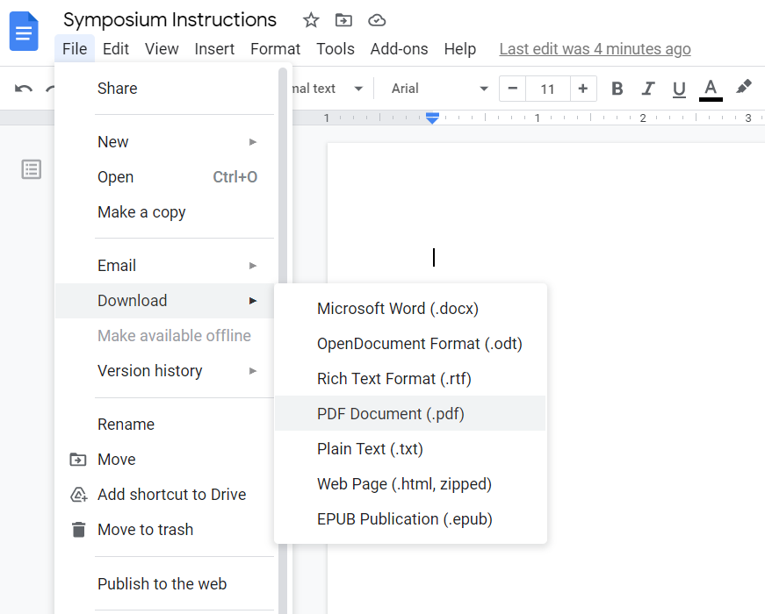
Power Point Slides or Word Documents
- After you are finished editing your materials, select the File tab on the top left and click Save As.
- Click Browse next to the open file icon and determine where to save your PDF from the pop-up window. Double-check the name of your file and rename it if you wish. From the Save as Type drop-down list, select PDF.
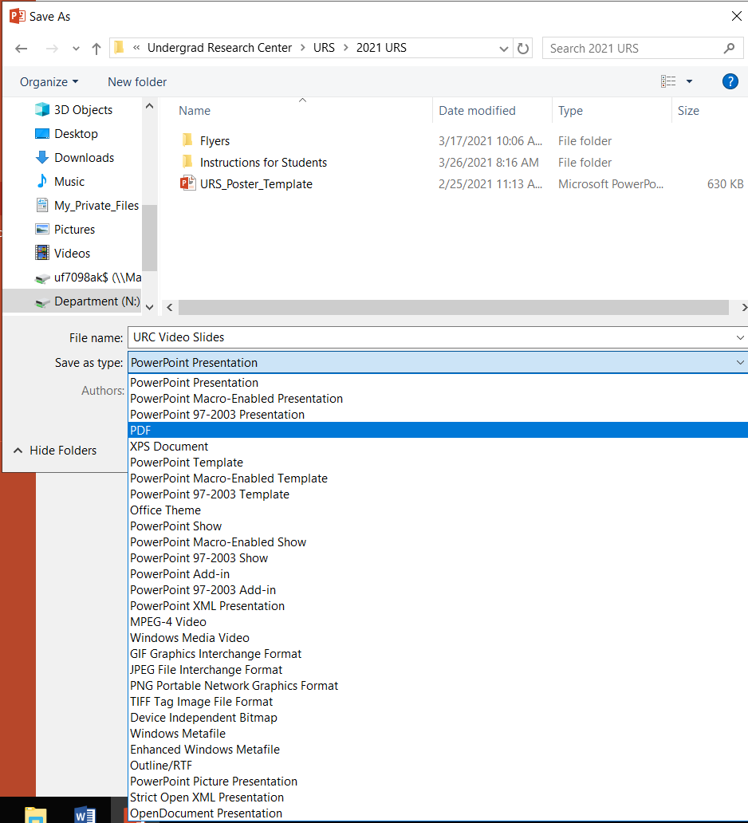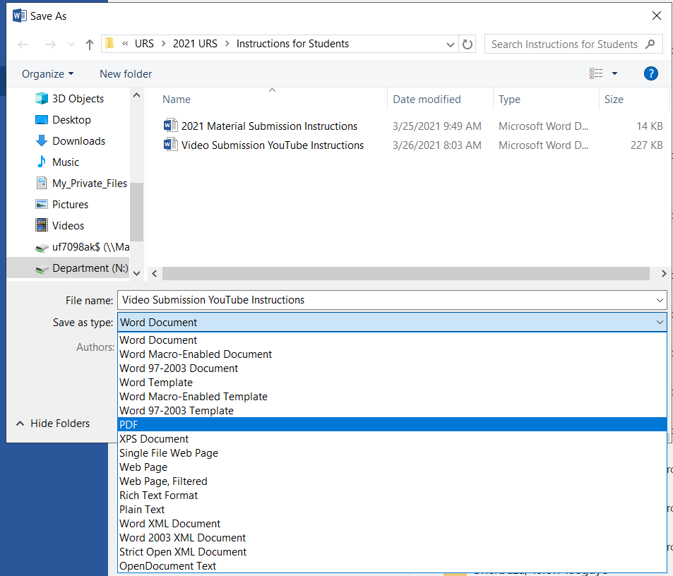
- Click Save.

