Undergraduate Research Symposium – Live! Presenter Guidelines

Congratulations on taking the first step toward presenting your research, scholarly, or creative work at the Undergraduate Research Symposium (URS). This year’s Symposium will be conducted a little differently than in the past. This year, the Symposium will have an in-person component (URS-Live!) and a virtual component (URS-Virtual!).

URS-Live! will be held on April 12th, 2022. Poster presentations, Oral presentations, and Creative exhibits will be held in the Centennial Student Union throughout the day. In addition, presentation materials for URS-Live! (posters, presentation handouts, and creative materials) will be available for viewing asynchronously by the public starting April 12th, 2022.

Each Poster will be assigned a 90-minute time slot to present during URS-Live! on Tuesday, April 12th. Each presentation must have at least one student presenter at their poster or exhibit throughout the entirety of the assigned time slot to share their work and answer questions. URS Judges will also be present during the session. Poster presentations will upload a brief voice-over video explaining the project and a PDF of the poster to the Symposium site. These materials will be available for asynchronous viewing and must be uploaded prior to April 12th, 2022.

Each Oral Presentation will be assigned to a one-hour session during URS-Live! on Tuesday, April 12th to present their work. Each presentation will be allowed 15 minutes total to present. Students should plan to present for 10-12 minutes and reserve the remainder of their time for Q&A. Students should create a slideshow to accompany their oral presentation. There will be a Moderator for each session to help manage this and URS Judges will also be present during the entire session. Oral presentations will upload a PDF of their presentation slides or additional handouts about their project. For virtual upload, the URC will record your live presentation on April 12th and it to your online upload. You must upload your slides or handouts prior to April 12th, 2022.

All URS – Live! Presenters should:
- Upload presentation materials prior to the event on April 12th, 2022 (see above).
- Check in at the desk in front of the CSU ballrooms prior to their presentation to receive their nametag and confirm their presentation time. The URC recommends checking in 20-30 minutes prior to your presentation time.
URS – Live! Oral Presentations should:
- Bring a USB or device that has your presentation saved on it so that you can access your presentation.
URS – Live! Poster Presentations should:
- Bring a printed version of their poster with them to their presentation. You should print your poster through the Wiecking Copy Shop prior to the event. The URC does not pay for poster printing and will not print your poster for you. Posters should be 48” x 36”.

2022 URS Presentation Upload Guidelines

Step 1
All materials for both URS-Live! and URS-Virtual! will be available for viewing online through Symposium by ForagerOne at the following website. Please review this entire document and prepare your information before you start the submission process. You must submit all your materials and information in one sitting. If your submission is by a group, the lead presenter should complete the submission at the following link:
https://symposium.foragerone.com/24th-annual-undergraduate-research-symposium/submission

Step 2
Input the following information about the presenters (Figure 1):
- First Name, Last Name, Email Address, and Level of the First Presenter.
- Select your college affiliation from the provided list and enter your department. If you are unsure of the name of your department, select
- If your project has multiple presenters, use the Additional Presenters button to add them.
Figure 1
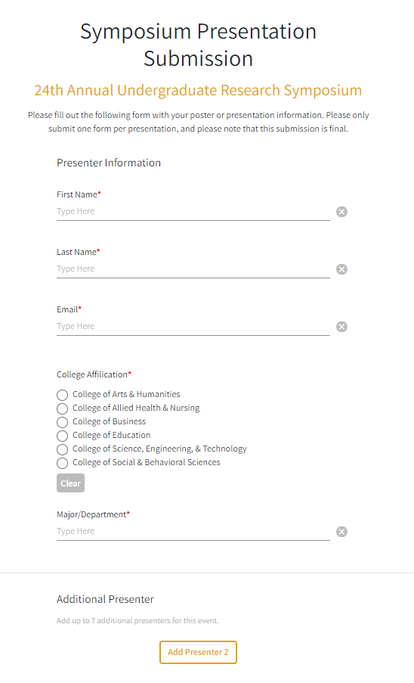

Step 3
Input the information about your presentation (Figure 2):
- Enter the Title of your presentation (Note: You can change this from what you submitted on the Intent to Present form).
- Enter the Abstract of your presentation (Note: You can change this from what you submitted on the Intent to Present). Make sure to check that any specific formatting required is correct.
- Enter your mentor’s name.

Figure 2
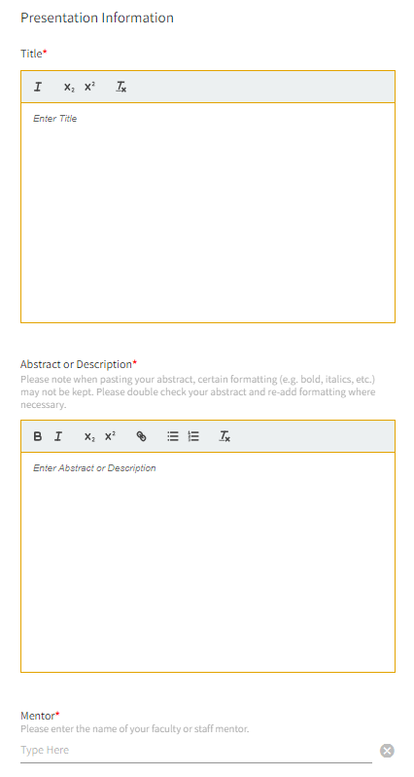
Step 4
It’s now time to confirm your presentation information and upload your presentation materials for the virtual component. What you submit will depend on what type of submission you have (Figure 3). Upload your documents and click the submit button.
- Poster – Select “Poster / Slides (PDF + Video)”. Upload your poster as a pdf file (10 MB or less in size). You are also required to upload a short voiceover video. It will appear in the upper left next to your poster and must be saved on YouTube (see additional instructions on this).
- Oral Presentation – Select the “Poster / Slides (PDF + Video)”. Upload a pdf file (10 MB or less in size) that will serve as a handout for your presentation. Examples of possible submissions could be a pdf version of your presentation slides, a one-page summary, or just a pdf copy of your cover slide. You may also link an OPTIONAL voiceover video. If you do, it will appear in the upper left next to your poster and must be saved on YouTube (see additional instructions on this). If you do not upload a voiceover video, the URC can record your presentation on April 12th and upload it for you.
- Creative Exposition – Contact the URC to determine the best format for your primary submission (urc@mnsu.edu). You may also link an OPTIONAL voiceover video. If you do, it will appear in the upper left next to your poster and must be saved on YouTube (see additional instructions on this).

Figure 3
